Health Safety and Environment Policy
Health Safety and Environment Department

1. Purpose

At Riverside our belief is safety first, where the safety of our employees, customers and the natural environment comes before anything else we do. Our work is never so urgent or important that we cannot take time to do it safely and with respect for the environment and each other.
The Riverside Group is one of the largest housing groups in the UK and therefore operates in many different geographical areas and offers multiple types of services which impact the lives of many people as well as the natural environment. Wherever we operate and whatever we do we must ensure, that we maintain safe and healthy workplaces, our safety-first culture and minimise the impact we have on the natural environment.
The Riverside Group is committed to:
- Building a safety-first culture that actively encourages positive health, safety and environmental practices through engaging with our people and those for whom we have a duty of care,
- Minimising any negative environmental impact of our current and future business practices,
- Wherever possible, seek opportunities to use safer fuel sources and energy efficient technologies and equipment,
- Complying with all applicable health, safety and environmental legislation and where appropriate going beyond compliance with the minimum requirements of regulatory bodies and customer expectations,
- Encouraging a fair and trusted, proactive reporting of health, safety and environmental issues, by applying just and learning investigation procedures,
- Caring for our employees and providing occupational health programmes and the promotion of wellbeing for our people,
- Ensuring robust health, safety and environmental risk mitigation strategies are in place to reduce negative impacts on colleagues, customers and the natural environment.

2. Scope

This policy set’s out the Health, Safety and Environment governance arrangements, roles and responsibilities for The Riverside Group, including all subsidiaries and business streams and Group Board. Employees at all levels must comply with the requirements of this policy.

3. Principles

HSE Policy Standard

3.1 Policy & Procedure
Health, Safety and Environment (HSE) Policies and Procedures (including work instructions) will be defined, documented, implemented, maintained and followed. This will be TRG’s HSE management system.
An accountable lead has been identified to deliver and embed all policies in their risk areas of the Group. Persons producing any HSE related policies must have suitable levels of competence and subject matter expertise in the relevant risk areas.
Systems and procedures will be appropriate and proportionate to the nature of the Group’s HSE risks.
Policies will define our legal duty and set out what we must or must not do to comply with laws, regulations and the practices that best protect the natural environment, our colleagues, customers, contractors and anyone else with whom we owe a duty of care.
Procedures will be developed in each area of the Group to meet the requirements of all policies that are applicable to that part of the group. Procedures can either be ‘Group Standard Operating Procedures’ meaning they cover the entire Group or ‘Local Operating Procedures’ which detail how a local area of the group operates in accordance with the Policy.
Where necessary, guidance documents will be written to support embedding the procedures in each area of the Group.
In line with Riversides Equality Diversity and Inclusion policy, policies and procedures will be subject to Equality and Impact Assessment (EIA) where they meet the screening criteria in the EIA tool kit.
Systems and procedures will be regularly reviewed (at least annually) to ensure they reflect legal responsibilities associated with applicable:
HSE laws, regulations and other legal requirements
National and regional standards
Industry codes and best practice
Contractual requirements
Systems and procedures will be made available to those working under the control of The Riverside Group so that they are aware of their individual HSE obligations. A HSE Managements system index is available on the Group HSE RIC page. [INSERT LINK]
The HSE policy statement demonstrates TRG’s commitment to HSE and is signed and authorised by the Group Chief Executive and applies to all parts of The Riverside Group. The

HSE policy statement is required by law to be displayed in all of the company’s properties. See Appendix A.

3.2 Safety First Culture
Management at all levels will understand how they influence the HSE Safety First Culture within their areas of responsibility, actively demonstrate that they care about HSE and seek ways to continually improve HSE Performance by leading by example.
Management should engage with employees and create a caring and trusted working environment where our people feel they can stop work if it is not safe and that they can raise HSE related concerns to their manager.

3.3 Incident Management
All Riverside employees have a strict obligation to report all HSE events which have Riverside involvement to their line manager who has a duty to investigate and ensure they are recorded on the Safety at Work Information Tool (SAW-IT) regardless of any other customer reporting requirements.
Post incident investigations will follow a just and learning process to ensure blame is not attributed unfairly to any individual and TRG learn and implement lessons from all HSE events.
We will meet all legal obligations to report significant events to an appropriate regulator, for example RIDDOR to Health and Safety Executive.
Managers will actively encourage proactive reporting in the form of hazard and near miss reports on SAW-IT, and ensure they are treated as seriously as actual accidents.
Effective critical incident management and business continuity plans will be developed, implemented, tested and reviewed by each part of the group.

3.4 Hazard and HSE Risk Management
Health and Safety hazards of our services, operations, equipment and facilities including those that impact on others which includes contractors, sub-contractors and volunteers, will be identified and risk assessed with appropriate controls implemented to eliminate and manage our risks.
Risk assessments will take in to consideration, the individual needs of our customers and colleagues and any individual considerations and reasonable adjustments we may need to make to ensure they can work in a healthy and safe manner.
Environmental hazards/aspects of activities and services will be identified, assessed and appropriate controls will be implemented to manage the risk.
Risk assessments will also be reviewed following serious incidents, legislative and prior to operational changes.

HSE risk profiles and risk registers will be developed by each business stream and subsidiary and will contribute to the Group HSE Risk Register.
A legal register will be defined to identify all HSE legislation that TRG need to comply with and we will evaluate how we comply with all legal requirements.

3.5 Planning, Objectives and Targets
The Group HSE team will develop a 3-5 years HSE improvement strategy in line with the Group Business strategy. Each year a specific improvement plan will be developed to deliver the overall Group HSE strategy.
The Group Head of HSE will develop an annual improvement plan, setting objectives and targets, to support the continual improvement of HSE management across the group.
Each subsidiary and business stream will develop their own annual HSE improvement plan, setting objectives and targets, to support the overall group HSE objectives.

3.6 HSE Resources
A HSE management structure will be implemented to support and guide the delivery of HSE policies, systems, objectives and targets, to review HSE performance and respond to significant incidents.
Appropriate competent resources to manage HSE risk and deliver HSE objectives and targets will be allocated by the senior management teams in each business stream and subsidiary.
Group HSE team are responsible for providing competent advice and overall assurance to Group Board and Executive Directors that all business areas are delivering to their risk management responsibilities, reporting in line with UK HSE regulations, looking to continually improve the overall HSE performance in their part of the Group.

3.7 Training, Awareness, and Competence
Riverside employees, contractors and sub-contractors will be competent (have the necessary knowledge, training and experience) to undertake their role in a safe and secure way, without causing harm to themselves any other persons and the environment.
The individual competency required to address all identified HSE risks and hazards will be assessed with training needs identified and delivered during the risk assessment process.
Training records will be maintained of individuals training and competency levels.

3.8 Consultation and Communication
Consideration will be given, through a consultation process, to the views of employees, third parties, subsidiaries and recognised unions in the HSE decision making, development of policies and systems, setting of objectives and targets, changes in work practices and hazard identification and assessment.
HSE Information will be communicated to and from employees and other interested parties.
Systems will be implemented to identify, record and address employees and third parties concerns and resolve conflicts or escalate to senior management.
The Groups HSE Risk committee, The Safety-First Group, will be used to effectively communicate between, business streams, subsidiaries and risk areas ensuring roles and responsibilities are understood and the sharing of best practices / lessons learnt are well known.
Each part of the Group will develop their own Health, Safety and Environmental committee comprised of union (where appointed) and non-union representatives with senior management as chair. Concerns and opportunities raised by business stream, subsidiary and functional HSE committees will be escalated to the Safety-First Group committee meeting.

3.9 Performance Measurement and Monitoring
HSE Performance will be reviewed by management, in relation to the Groups HSE objectives and targets, and any necessary remedial and improvement action will be taken.
Overall HSE performance will be monitored and reviewed against agreed objectives and targets by the Executive Management team.
The Group HSE team will support the business by providing monthly performance reports from all HSE reporting systems to enable the business to make informed decisions.

3.10 HSE Compliance Assurance Audits
The HSE Management system will be periodically reviewed (at least annually or sooner if there is a business need) to determine if the system is adequate to control the business risk. Annual HSE compliance assurance reviews will take place in each business stream, subsidiary and functional area to provide assurance to the Chief Executive Officer and Executive Management team that each part of the Group are managing safety.

4. Further Information & Support

Underpinning HSE procedures and guidance documents are currently under review, and will be updated in due course.

5. Roles and Responsibilities

Governance Arrangements and Responsibility Arrangements
The Health and Safety Governance structure is set out below and describes how The Riverside Group will govern HSE across all parts of the Group. The Governance framework details who has governance responsibilities and how we shall report on our Governance frameworks.
It shows how both Operational and Strategic HSE risk information flows throughout the organisation.
The HSE governance and performance is assured by the Group HSE function who will highlight areas of good practice, identify areas of improvements and monitor the effectiveness of the Governance arrangements.
Riverside Scotland, as a separate legal entity, has its own legal health and safety responsibilities, including as an employer and landlord. The Board Members of Riverside Scotland will retain responsibility for ensuring that Riverside Scotland meets these legal obligations. The Riverside Scotland Board can delegate operational oversight of health and safety compliance; however, it should be noted that Riverside Scotland Rules do not currently permit this Board to delegate responsibilities to non-Riverside Scotland employees. For the purposes of the Governance arrangements set out below in section 4.1 Riverside Scotland Association is categorised as a subsidiary board.

  - Summary of governance responsibilities
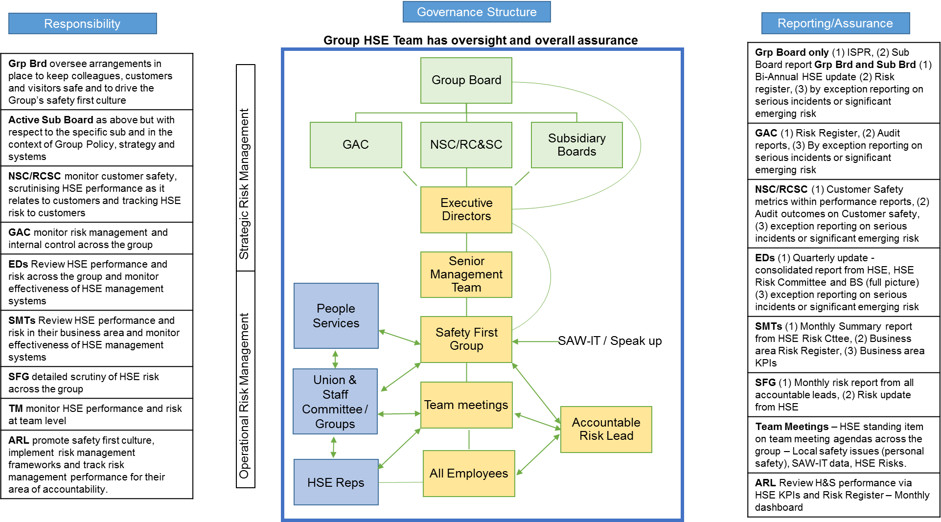
  - Group Roles and Responsibilities
Role | Responsibilities
The Riverside Group Board | The TRG Group Board will  Authorises the HSE strategic plan and monitors progress to the plan.  Positively reinforces the safety first culture.  Receive and review the annual HSE report on the robustness of the Groups HSE management system.  Receive assurance that any weakness in the HSE management system are being addressed by Executive Director’s and accountable leads for HSE.  Ensure the Group have allocated adequate resources to successfully manage HSE risks to an acceptable level.
Subsidiary Boards | The TRG Subsidiary Board will:  Authorises their HSE strategic plan, ensuring it aligns to the group plan, and monitors progress.  Positively reinforces the safety first culture.  Receive and review regular HSE performance reports on subsidiary objectives, targets and accident / incidents.  Receive assurance that any weakness in the subsidiary HSE management system are being addressed by their leadership group.  Ensure they have allocated adequate resources to successfully manage HSE risks to an acceptable level across the subsidiary.
Group Chief Executive | The TRG CEO will:  Ultimate responsibility for HSE performance and risk management across the Group,  Actively leads by example fostering a positive safety first culture,  Strive for continual improvement by ensuring HSE objectives are being set and monitor progress against them,  Ensure that HSE expectations are made clear to the Executive Directors,  Include HSE as a regular item on Executive Directors meetings,  Monitor HSE compliance assurance reviews and ensure any remedial actions are implemented in agreed timescales,
Managing Director of Subsidiary Riverside Scotland | The authorised officer with responsibility for oversight of Riverside Scotland health, safety and Environment compliance,  Ensures robust HSE management system is in place that meets or exceeds the TRG’s standards for HSE,  Actively leads by example fostering a positive safety first culture,  Strive for continual improvement by ensuring HSE objectives are being set and monitor’s progress against them,  Ensure that HSE expectations are made clear to senior Directors,  Include HSE as a regular item on Senior Directors meetings,  Monitor HSE compliance assurance reviews and ensure any remedial actions are implemented in agreed timescales,
Group Executive Directors Team | The Group Executive Directors Team collectively will:  Identify a sponsor to lead the HSE risk committee – Safety First Group  Review Group HSE performance seeking areas of best practice to share across the group and taking remedial action for areas of poorer performance,  Monitor effectiveness of the HSE management system,  Make sure HSE expectations are made clear to senior leadership / management teams,  Consider HSE requirements when appointing staff at senior management and executive levels.  Ensure the safety of our colleagues, customers and the natural environment come before anything else we do,  Provide adequate resources to ensure we can achieve the highest possible HSE standards and performance,  Positively reinforce good HSE practices and seek ways to continually improve our HSE management systems.
Executive Directors | Executive Directors, individually will:  Be responsible for HSE within Directorate,  Ensure HSE expectations are made clear to senior management teams,  Include HSE as a standard item on SMT agendas,  HSE management structure is implemented to deliver policies and procedures,  Lead by example, ensuring safety first is considered as part of everything we do,  Ensure all risks have been assessed and control measures are in place to reduce risks to tolerable levels,  Ensure training needs are met and adhered to,  Review HSE performance of their business area,  Attend HSE Training sessions when required,  Ensure any issues identified are followed through with necessary remedial actions  Provide adequate resources to achieve the objectives and targets set within the HSE management system,  Review and agree Group quarterly report,  Ensure effective communication between management, colleagues, customers  Escalate HSE issues to the Executive team and Group Board,  Ensure Health and Environmental protection controls are given equal priority to safety,  Challenge unsafe acts and behaviours by applying a learning and fair process.
Accountable Risk Lead | All accountable risk leads for TRG will:  Develop policies, procedures and risk frameworks for nominated risk area,  Ensure HSE management system is implemented, known and embedded for their risk area,  Work collaboratively with other accountable leads to ensure sharing of best practice.  See section 4.3 Accountable Risk Leads Roles and Responsibilities
Senior leaders / management teams | The Senior Leadership/Management Team will:  The health and safety of persons whom report to them and the impacts on the natural environment from the work we do,  Include HSE as a standard item on SMT agendas,  Chair / support their area HSE employee committee meeting,  Include HSE targets and objectives in local business plans to meet the Group strategy,  Engage with their colleagues with regards to attitudes and behaviours towards HSE,  Consider HSE requirements when appointing to Management positions,  Ensure arrangements are in place to manage HSE and minimise our impacts on the environment,  Ensure they understand the laws we need to comply with and develop legislation or legal registers across their areas of control,  Develop and own the HSE risk register for their areas,  Monitor HSE performance and seek ways to continually improve,  Ensure risk assessments are in place to cover all workplace activities and individuals,  Participate in all HSE training identified as for their role,  Ensure all adverse HSE events are investigated following a just a learning process,  Provide adequate resources to ensure HSE is managed effectively,  Challenge unsafe acts and behaviours by applying a just and learning process.
Operations / people managers | Operational Managers are responsible for:  The health and safety of persons whom report to them and the impacts on the natural environment from the work we do,  Leading our safety first culture and ensure they demonstrate customer, colleague and the natural environments safety and care as our number one priority,  Ensuring risk assessments are in place for their direct employees, services, themselves and their teams,  Training needs of their employees are identified and that employees attend all training courses / sessions that are provided to keep them safe in their role,  Ensuring colleagues are provided with the correct tools and equipment for the tasks required of them,  Ensuring personal protective equipment is provided as identified through individuals risk assessments,  Ensuring Occupational health support is provided to ensure occupation health controls are suitable to ensure colleagues occupational health is not adversely affected,  Ensuring accidents and incidents are recorded and investigated appropriately to ensure root causes are identified and addressed,  Ensuring all agreed actions raised resulting from inspections, risk assessments, reviews and audits are implemented in agreed timescales,  Ensuring Health and Environment are treated with equal importance as safety,  Ensuring Health, safety and environment is included as an agenda item on team meetings to ensure colleagues had the opportunity to raise any issues that concern them,  Demonstrating we care – Managers are to talk to colleagues about their health and wellbeing and safety or environmental concerns during 1:1 meetings,  Ensuring HSE objectives are set as personal objectives,  Ensuring any work that may affect the public, our customers and the natural environment is carried out with care and is planned not to have an adverse impact.  Encouraging our colleagues to engage with health, safety and environmental management process by allowing them time and resources to work safely and to stop work if it is not safe, could damage the natural environment.  Providing safe work places and ensure they are regularly inspected,  Developing safe systems of work consisting of written work instructions, procedures, risk assessments and compliance checks.
All Employees | All Riverside employees must:  Take reasonable care of themselves and others health and safety,  Stop work if it is not safe, re-evaluate the hazards and report any harmful working practices to their manager,  Report all hazards, near misses, accidents and incidents on SAW-IT and or directly to their manager,  Support their manager in completing individual risk assessments,  Following all risk controls, safe systems of work, policies, procedures and safety rules,  Use all safety related equipment as instructed that is provided to them by TRG,  Undertake training provided and ensure all mandatory training is kept up to date.
Head of Health Safety and Environment | Head of Health Safety and Environment and the HSE Team will:  - Develop the Group HSE Strategy in line with the Group business strategy  - Provide technical guidance to Group Board and Executive Directors,  - Provide the Group with meaningful monthly HSE performance data,  - Produce annual Group Board report and quarterly Executive Directors report,  - Support the business with technical solutions to deliver their risk frameworks,  - Ensure the business understands its legal obligations and risk profiles,  - Provide compliance assurance reviews to ensure all parts of the Group are operating to the highest practicable standards to assure the Group Board and Executive Directors,  - Provide technical advice and guidance to Senior Leaders, Managers, and accountable risk leads,  - Manage the continual improvement of enterprise HSE applications,  - Identify trends and provide solutions the business can implement to mitigate risks,  - Horizon scan to ensure Riverside is prepared for emerging risk and changing legislation,  - Lead investigations into major events that occur, ensuring we apply a just and learning process.

  - Accountable Risk Leads Roles and Responsibilities
Accountable risk leads are accountable for Health, Safety and Environment for their specific risk area; the Group Health and Safety function will provide assurance that the Accountable risk leads are complying with HSE requirements on behalf of The Riverside Group. The key risk areas are;
- Our Office Estate - where staff work and customers/stakeholders visit
- Our Colleagues and agency workers/consultants
- Our customers:
  - Care and Support,
  - Social Housing,
  - Home Ownership

- Our stock and communal areas where customers live
- Our buildings contractors (Evolve, Prospect, Development contractors)
- External partners, key suppliers and 3^{rd.} parties – Development and Growth and Procurement.
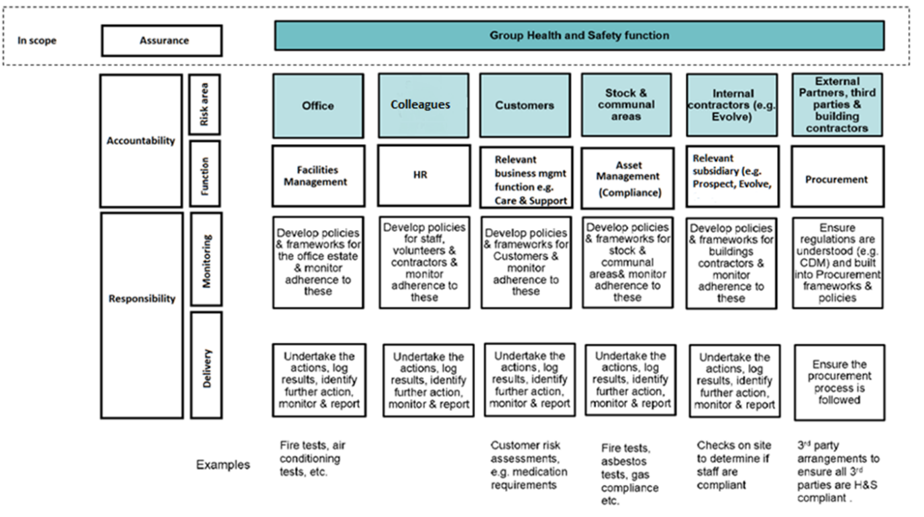

The Group Health Safety and Environment function provides an assurance role across the group. The Group HSE function are not responsible The Group HSE Functions responsibilities are set out in the table below:
Assurance | - Establish and maintain group wide HS&E management systems and accreditations (e.g. RoSPA & ISO 18001).  - Undertake random sampling against the framework, to ensure all risk areas have policies and procedures which are being complied with.  - Take ownership for strategic HSE risk mapping and allocation of responsibilities and make sure this is always kept up to date.  - Ensure appropriate measures are in place to provide assurance to Group Board and Audit Committee that our risks are being managed.
Overseeing Delivery | - Create strategic frameworks to inform how business areas develop their respective frameworks and policies.  - Ensure a consistent approach to how we monitor and report data against the key risk areas  - Ensure ownership of risk has been allocated to the appropriate responsible person  - Provide HS&E expertise across the organisation and act as a critical friend to the business areas, where required  - Understand changes to HS&E and disseminate these across TRG  - Embed a HS&E culture across the organisation with support from Marketing and Communications  - Ensure staff are provided with the tools and training to undertake investigations within their risk areas with support from Learning and Development  - Develop and implement a HS&E continuous improvement strategy for Riverside  - Establish a robust & consistent framework for the reporting and investigation of accidents, incidents and near miss investigations -  - Undertake appropriate reporting to the required governing bodies (e.g. RIDDOR)  - Perform escalated independent HS&E investigations within agreed thresholds  - Ensure appropriate governance is in place to support issue escalation
HSE Interface | - Act as the main interface with the HSE, LA enforcement & other key external stakeholders on behalf of |TRG (note, the business areas will own the relationship with their stakeholders)

Accountable risk leads responsibilities and key deliverables are set out in the table below:

Risk Area | Accountable delivery agent | Responsibilities
Our Offices | Head of Facilities Management | - Develop and embed HSE related policies, procedures and frameworks for our office estate.  - Monitor compliance to HSE frameworks and conduct essential building checks across our Offices.  - Ensure risk assessments are in place for our offices.  - Identify opportunities for improvements by developing a risk register for our offices.  - Ensure we are compliant to all legislation relating to our offices using a legal register.  - Provide monthly update to SFG on risks, issues and improvements.  - Develop Annual HSE improvement plans for our offices.  - Complete all improvements actions as identified in HSE compliance assurance reviews.  - Develop and own business continuity plans for our offices.
Our People (Staff, Volunteers and Contractors) | Director of People and Culture | - Develop and embed HSE related policies, procedures and frameworks to protect our people.  - Monitor compliance to HSE frameworks and monitor adherence to process and procedures.  - Ensure risk assessments are in place for our people.  - Provide systems and processes to protect our peoples personal safety (training, Occupational Health, personal safety devices, Warning markers, reasonable adjustments, major incidents)  - Identify opportunities for improvements by developing a risk register for our people.  - Ensure we are compliant to all legislation relating to our people using a legal register.  - Provide monthly update to SFG on risks, issues and improvements.  - Develop Annual HSE improvement plans for our people.  - Complete all improvements actions as identified in HSE compliance assurance reviews.
Our Customers | RC&S – Head of Quality and Compliance  RHO – Director of RHO  Social Housing – Head of Social Housing Business Management | - Develop and embed HSE related policies, procedures and frameworks to protect our customers.  - Monitor compliance to HSE frameworks and monitor adherence to process and procedures.  - Ensure risk assessments are in place for our customers.  - Provide systems and processes to protect our Customers (Person Centred Fire Risk assessments, PEEP’s, customer care inspections, new tenant induction checks).  - Identify opportunities for improvements by developing a risk register for our customer’s safety.  - Ensure we are compliant to all legislation relating to our customers using a legal register.  - Provide monthly update to SFG on risks, issues and improvements.  - Develop Annual HSE improvement plans for our customers.
Our Stock and Communal Areas | Director of Building Safety | - Develop and embed HSE related policies, procedures and frameworks to protect our stock and communal areas:  - Heating and Ventilation  - Fire Safety  - Electrical Safety  - Asbestos Management  - Water Hygiene  - Mechanical and lifting  - Communal areas – Car Parks and Play equipment  - Monitor compliance to HSE frameworks and monitor adherence to process and procedures.  - Ensure risk assessments are in place for our stock and communal areas.  - Provide systems and processes to protect our stock and communal areas (emergency equipment, inspections, test equipment)  - Identify opportunities for improvements by developing a risk register for our stock and communal area safety.  - Ensure we are compliant to all legislation relating to our stock and communal areas using a legal register.  - Provide monthly update to SFG on risks, issues and improvements.  - Develop Annual HSE improvement plans for our customers.  - Complete all improvements actions as identified in HSE compliance assurance reviews.
Our Internal Contractors | Evolve – Head of Health and Safety  Prospect – Head of Construction | - Develop and embed HSE related policies, procedures and frameworks for our internal contractor’s safety.  - Monitor compliance to HSE frameworks and conduct essential checks across our internal contractors.  - Ensure risk assessments are in place for our internal contractors operations.  - Identify opportunities for improvements by developing a risk register for our internal contractor’s risks.  - Ensure we are compliant to all legislation relating to our internal contractors using a legal register.  - Provide monthly update to SFG on risks, issues and improvements.  - Develop Annual HSE improvement plans for our internal contractor’s operational areas.  - Complete all improvements actions as identified in HSE compliance assurance reviews.  - Develop and own business continuity plans for our internal contractors operational areas.
External partners, third parties and building contractors | Head of Procurement | - Ensure Contractors are suitably competent and have correct accreditations / insurances to conduct works on behalf of TRG.  - Own the approved contract register and conduct essential supplier checks across our supply chain.  - Develop and embed HSE related policies, procedures and frameworks for our procurement supply chain.
External partners, third parties and building contractors | Contract owner | - Only use Contractors on the approved contract register.  - Ensure local contractor inductions are conducted and TRG’s expectations are met.  - Ensure checks are in place to evaluate contractor’s competence and safety performance.  - Ensure Procurement are aware of any poor performing contractors.  - Ensure we are compliant to all legislation relating to the management of our contractors (CDM, permit to work) using a legal register.

6. Risk Thresholds

Risk Appetite | Risk Thresholds | Risk Indicators
- We seek to avoid legal or regulatory breaches for HSE.  - We seek to minimise our HSE risks to the greatest extent possible. | - Compliance with all legal and regulatory requirements for HSE.  - Zero employee fatalities (work related, including driving on business)  - Zero customer fatalities due to a HSE incident at the RHG property  - Irreversible damage | - Number of health & safety related fatalities or catastrophic injuries.  - Number of breaches to health & safety legislation leading to prosecution  - Reported employee accident rate below industry standard  - RIDDOR reports below industry standard  - Percentage major health & safety incidents <5% of total incidents reported

7. Equality, Diversity and Inclusion

Riverside is committed to Equality, Diversity & Inclusion. We strive to be fair in our dealings with all people, communities and organisations, taking into account the diverse nature of their culture and background and actively promoting inclusion. This policy aligns with Riverside’s Equality, Diversity and Inclusion Policy and has been subject to an Equality Impact Assessment.

